Michelle Foster-Keevers
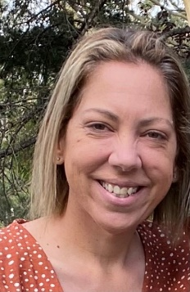
From the age of 15 Michelle Foster has worked with kids and community, this passion and commitment has grown and sustained Michelle the 25 years she has worked in the community sector.
This work has included time working for leading NGO’s, known for her innovative and creative ways of supporting and working with community to utilize their cultural strength to generate Aboriginal solutions to generate the best outcomes for kids, families, and communities.
Michelle was introduced to the Winangay carer assessment tool in 2011 and from that moment, grew a passion, to be part of the change and innovation which she knew was so desperately needed. Working alongside the Winangay team in training and undertaking assessments Michelle introduced the Winangay tools to Aboriginal and non-Aboriginal service providers.
Respected across the sector Michelle run her own consultancy, until recently due to unexpected illness, and is a skilled, respectful, and inclusive facilitator. Often asked to conduct complex challenging assessments Michelle has used the Winangay tools to hear the voice of kids, families, and communities, telling their stories their way and together compelling evidence to support her decision making. At every step along the way Michelle has embedded Aboriginal Family led decision making to ensure kids are safe with family, raised in culture and on country.
The founder of Ngaramura Indigenous Corporation she works closely with young Aboriginal, Maori and Pacific Islander children and young people in community, and their families. Her mission is clear, Strengthening our children and young people’s culture and identities in partnership with families and communities. Strong Identities, Safe Families and Love in Culture.

